System Settings

What Are System Settings?
# Source: AI Source: Provided by: [Data Path: Persons Table -> ID Column: 1, Name_En Column: Motasem Essam] -> From: [Chatgpt (GPT‑5 Mini)] on [1/26/2026]
System settings are configurable options in an operating system or software environment that control how the system behaves. They are like rules or preferences that tell your computer how to operate.
Think of them as the “control panel” for your computer or system environment.

Key Characteristics
# Source: AI Source: Provided by: [Data Path: Persons Table -> ID Column: 1, Name_En Column: Motasem Essam] -> From: [Chatgpt (GPT‑5 Mini)] on [1/26/2026]
- System-wide – They affect the entire computer or a large part of it.
- Persistent – They usually stay the same even after restarting your computer.
- Configurable – Users or administrators can change them to adjust system behavior.
- Separate from application code – Unlike hardcoded settings in programs, system settings are stored at the OS level.

Examples of System Settings
# Source: AI Source: Provided by: [Data Path: Persons Table -> ID Column: 1, Name_En Column: Motasem Essam] -> From: [Chatgpt (GPT‑5 Mini)] on [1/26/2026]
Operating System Settings
- Display settings: resolution, brightness
- Sound settings: volume, default speakers
- Time and date: timezone, clock format
- Language & keyboard layout
- Network settings: Wi-Fi, proxy, VPN
Security & Access
- User accounts and passwords
- Firewall settings
- Permissions for files and folders
Environment-related
- PATH variable (where the system looks for executables)
- System-wide environment variables
- Startup programs (which apps run when the OS starts)

How They Differ from Environment Variables
# Source: AI Source: Provided by: [Data Path: Persons Table -> ID Column: 1, Name_En Column: Motasem Essam] -> From: [Chatgpt (GPT‑5 Mini)] on [1/26/2026]
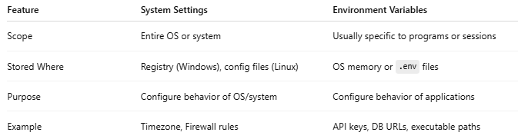
Feature | System Settings | Environment Variables
Scope | Entire OS or system | Usually specific to programs or sessions
Stored Where | Registry (Windows), config files (Linux) | OS memory or .env files
Purpose | Configure behavior of OS/system | Configure behavior of applications
Example | Timezone, Firewall rules | API keys, DB URLs, executable paths

Why System Settings Are Important
# Source: AI Source: Provided by: [Data Path: Persons Table -> ID Column: 1, Name_En Column: Motasem Essam] -> From: [Chatgpt (GPT‑5 Mini)] on [1/26/2026]
- Ensure your OS and applications run smoothly
- Control security and privacy
- Customize the system to your needs (performance, accessibility, appearance)
- Provide a consistent environment for programs to run

System Settings Examples
# Source: AI Source: Provided by: [Data Path: Persons Table -> ID Column: 1, Name_En Column: Motasem Essam] -> From: [Chatgpt (GPT‑5 Mini)] on [1/26/2026]
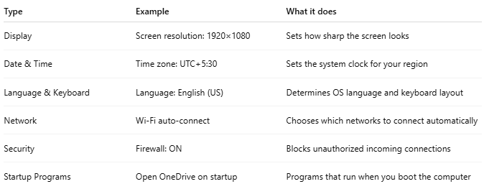
Type | Example | What it does
Display | Screen resolution: 1920×1080 | Sets how sharp the screen looks
Date & Time | Time zone: UTC+5:30 | Sets the system clock for your region
Language & Keyboard | Language: English (US) | Determines OS language and keyboard layout
Network | Wi-Fi auto-connect | Chooses which networks to connect automatically
Security | Firewall: ON | Blocks unauthorized incoming connections
Startup Programs | Open OneDrive on startup | Programs that run when you boot the computer

💡 Analogy:
# Source: AI Source: Provided by: [Data Path: Persons Table -> ID Column: 1, Name_En Column: Motasem Essam] -> From: [Chatgpt (GPT‑5 Mini)] on [1/26/2026]
If your computer is a house, system settings are the main switches for electricity, water, heating, and locks—while environment variables are more like room-specific instructions, like “this lamp uses a dimmer” or “this door needs a special key.”

